EXPERIMENT – 20
MYSQL String Functions- REPLACE, REPEAT, REVERSE, RIGHT, LEFT, RPAD, LPAD
REPLACE, REPEAT, REVERSE, RIGHT:
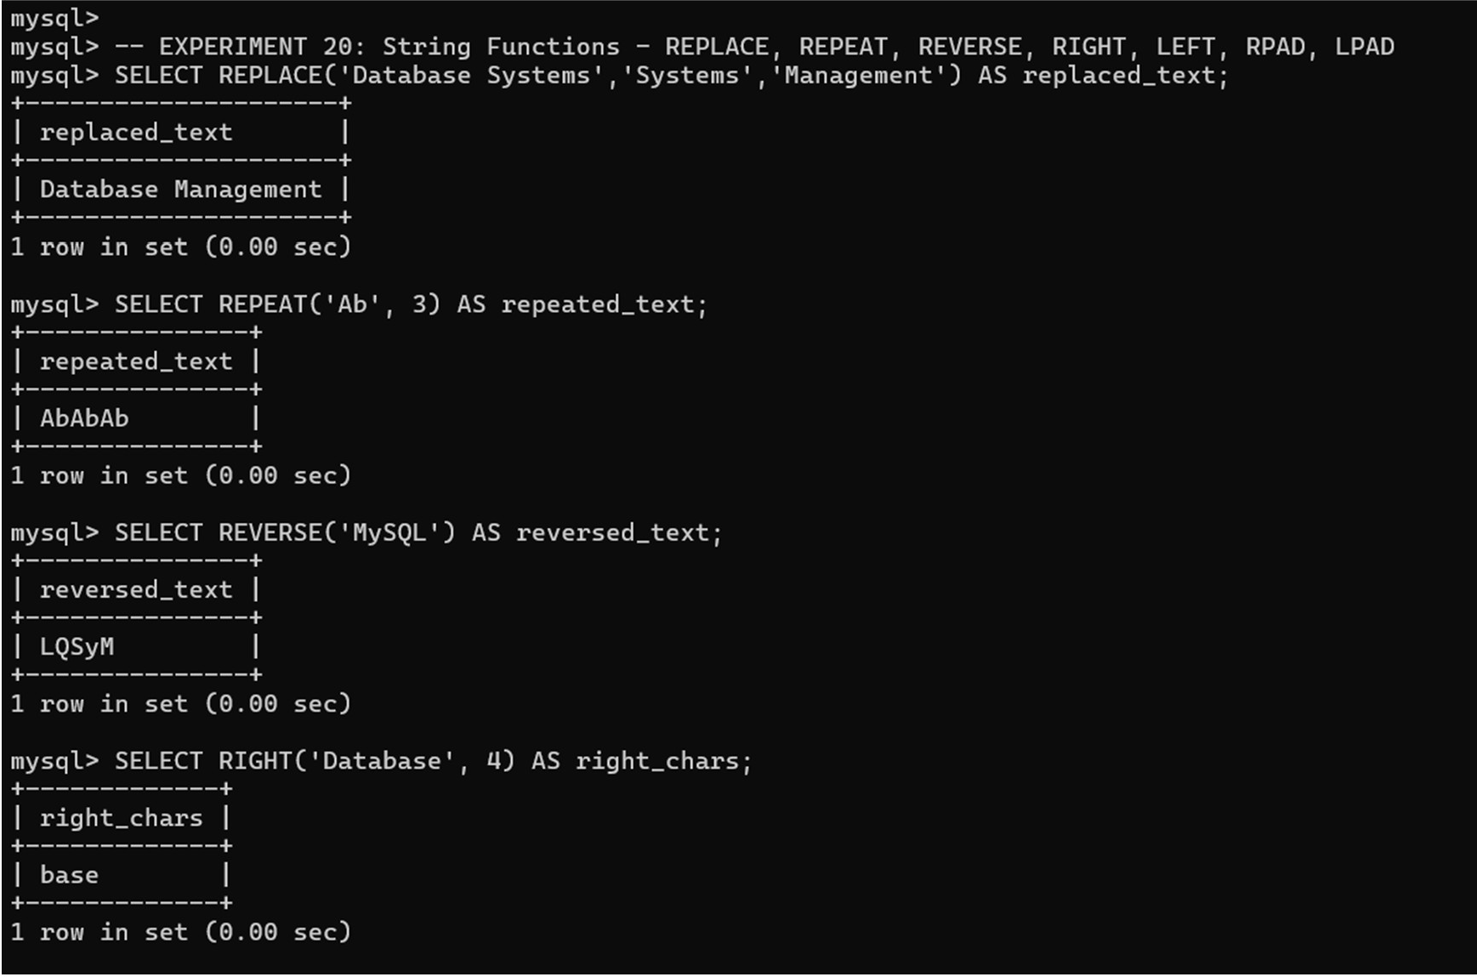

LEFT, RPAD, LPAD:
